**Assisted Practice: 3.13 Empty an S3 Bucket**

This section will guide you to:

* Empty an S3 bucket

This lab has three subsections, namely:

3.13.1 Selecting the S3 bucket you want to empty

3.13.2 Emptying the bucket

3.13.3 Pushing the files to GitHub repositories

**Step 3.13.1:** Selecting the S3 bucket you want to empty

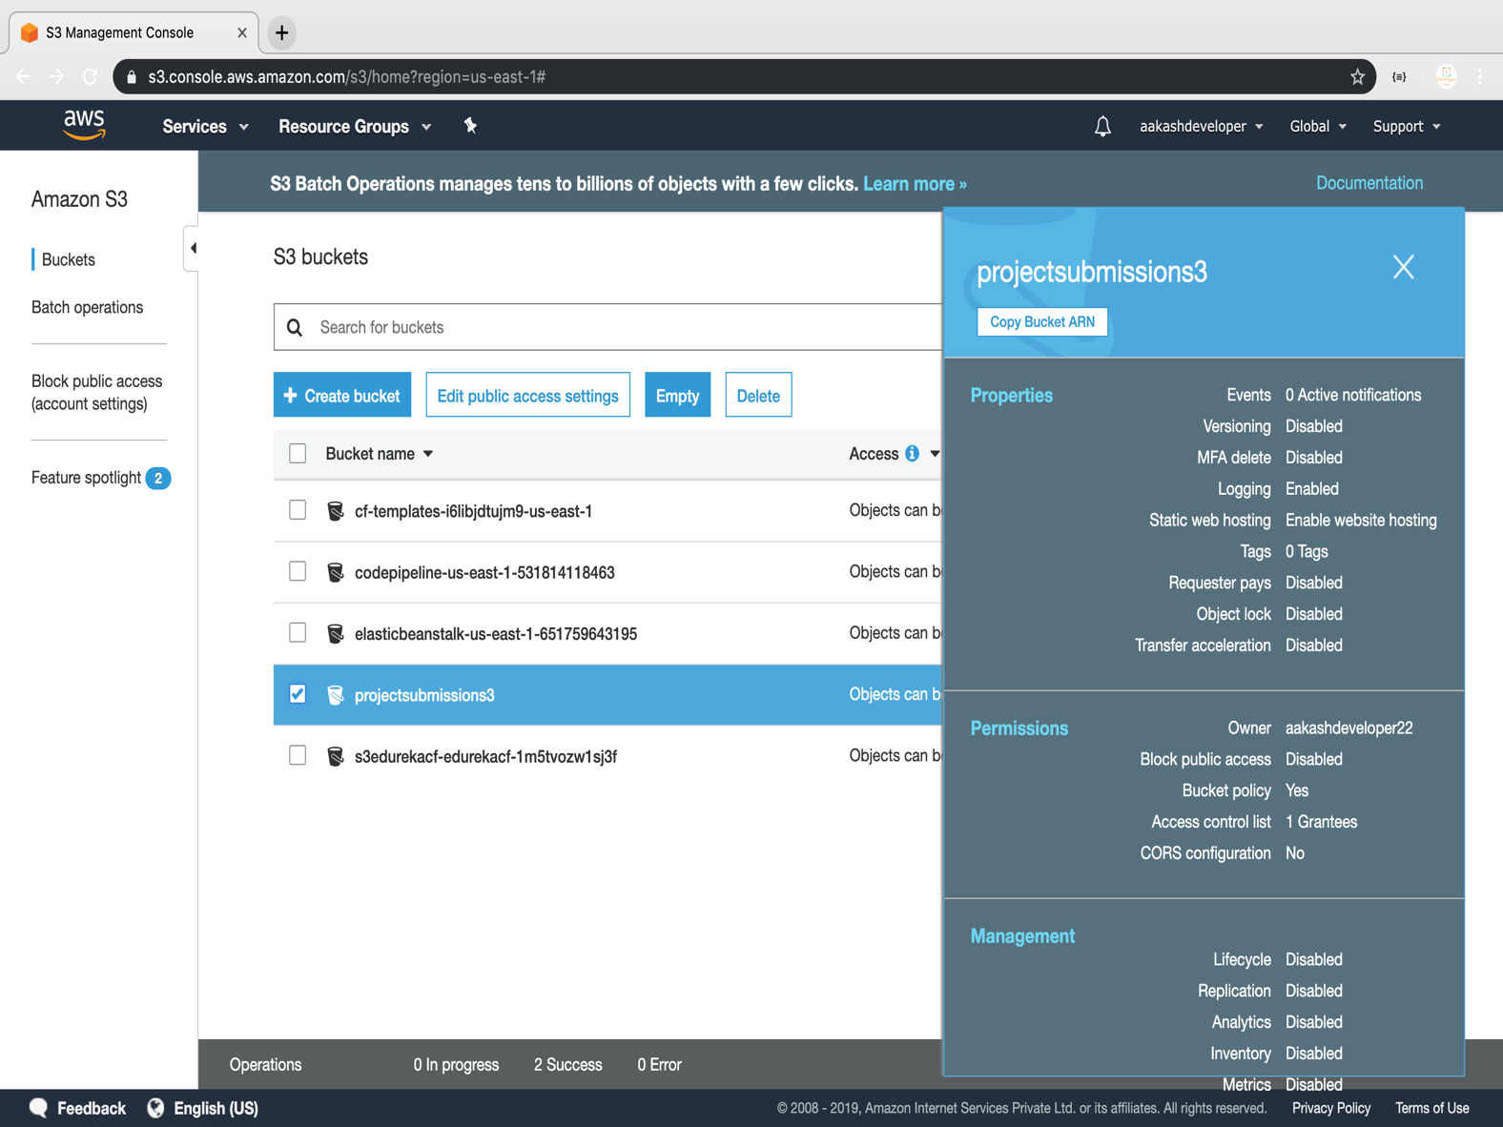

**Step 3.13.2:** Emptying the bucket

* Verify the content present in the bucket

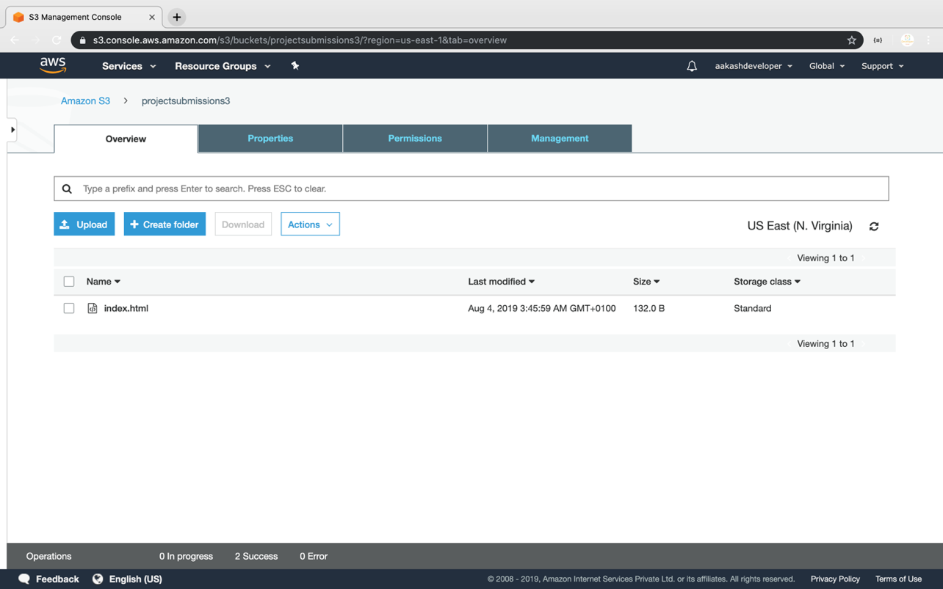

* Empty the bucket

